**Name : Sarthak Modak Final Year ECE AIML**

**PRN : 1032212305 Batch : FSD G1**

**FSD Laboratory 02**

Aim: Design and develop a responsive web page using Bootstrap front end framework.

Objectives:

1. To understand HTML tags

2. To learn the styling of web pages using CSS

3. To learn Bootstrap Front End Framework.

Theory:

1. Bootstrap Grid System.

* The **Bootstrap Grid System** is a **flexible layout system** based on a **12-column structure**. It allows you to create responsive layouts using rows and columns.

**Key Features of Bootstrap Grid**

**12-column structure**: You can divide the page into up to 12 columns.  
**Breakpoints**: Adjusts the layout based on screen size (Extra Small, Small, Medium, Large, Extra Large).  
**Nested Grids**: You can nest rows and columns inside another column.  
**Predefined classes**: .col-, .col-sm-, .col-md-, .col-lg-, .col-xl-.  
**Flexbox-based**: Uses CSS Flexbox for better alignment.

2. Bootstrap .container and .container-fluid class.

**1. .container (Fixed Width)**

* Creates a **fixed-width** container.
* Adjusts width at different breakpoints.
* **Has auto margins** to center content.

**2. .container-fluid (Full Width)**

* Stretches to **100% of the screen width**.
* Useful for **full-width layouts**.

FAQ:

1. What is a responsive website?

A **responsive website** is a web page that **adjusts its layout, images, and content** based on different screen sizes and devices (Mobile, Tablet, Desktop).

**Characteristics of a Responsive Website:**

**Flexible Grid Layouts** – Uses percentages instead of fixed pixels.  
**Media Queries** – Adapts styles based on screen width.  
**Responsive Images** – Images resize according to screen size.  
**Mobile-Friendly Navigation** – Menus and buttons adjust for small screens.

2. How Bootstrap helps to design a responsive website?

Bootstrap simplifies responsive web design with built-in classes and features:

**Grid System** – Creates flexible, responsive layouts.  
**Predefined Breakpoints** – Automatically adjusts elements based on screen size.  
**Responsive Components** – Navigation bars, carousels, forms, and buttons adapt to different devices.  
**Utility Classes** – Built-in classes like .d-none, .d-sm-block, .text-center, etc., help style elements dynamically.  
**Mobile-first Approach** – Designed to prioritize mobile devices and scales up for larger screens.

Output: 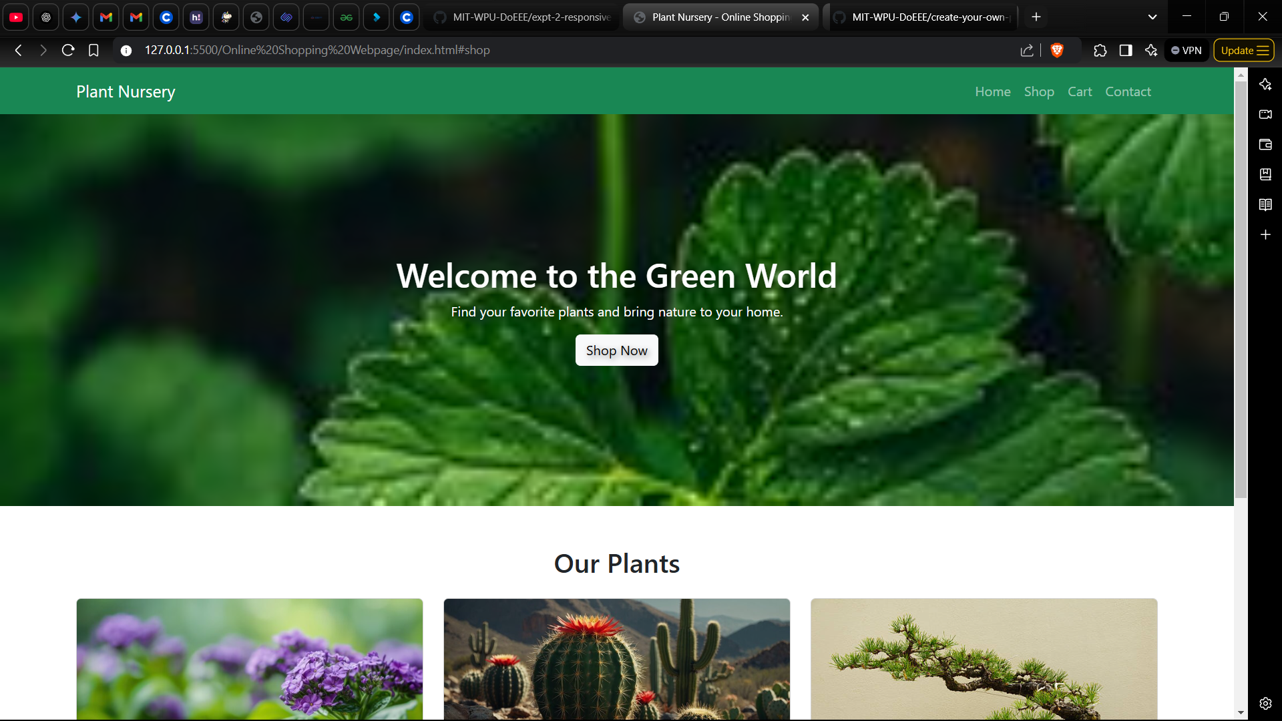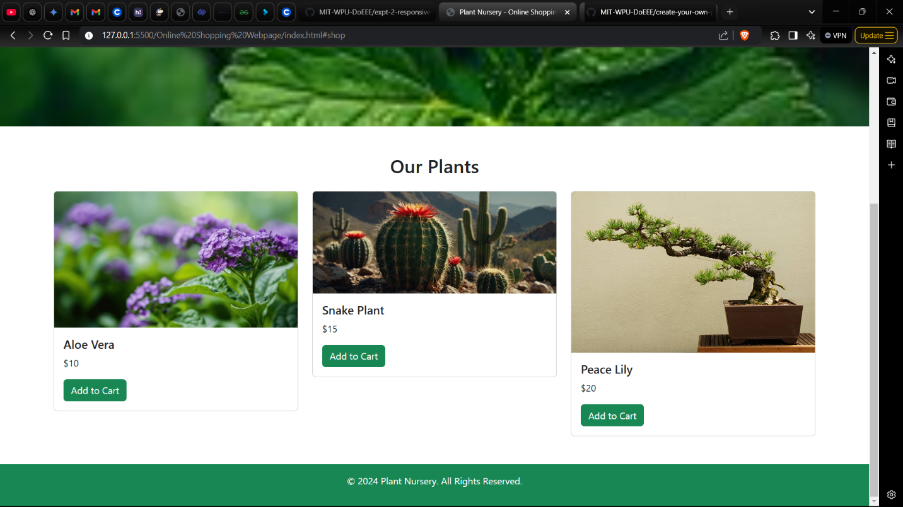

**Problem Statement:**

Design and develop a responsive web page (For example student registration, course enrollment, library management system, online shopping system etc.) using Bootstrap front end framework. Web pages should contain HTML5 elements (Use all possible formatting for example font, colour etc.).

Web page should include various

* images,
* links within the page,
* tables
* lists
* form elements
* paragraphs
* links to other pages for navigation,
* new tabs.

Use Cascaded Style Sheets (CSS) to style the web pages designed. Make use of

* Three types of styles (Inline, Internal and External)
* border,
* margins,
* padding,
* navigation,
* dropdown list
* tag selector
* class selector
* id selector
* exploring background image and position property etc.